INSTRUCTIONAL OBJECTIVES (Pages 322 – 327, and pages 381 – 383, ending with Example 4)
Students will understand and apply the following concepts:
- Definitions of the 6 trigonometric functions using right triangle trigonometry.
- Evaluation of the 6 trigonometric functions with a calculator.
- Evaluation of the 6 trigonometric functions of the special angles (30º, 60º, 45º).
- Application of right triangle trigonometry to actual situations.
- The significance of angle of depression and angle of elevation.
- The relationship between the pairs of trigonometric cofunctions.
Technology: Graphing calculator (TI-83 or TI-84)

TUESDAY (9.17.24)
Discuss the following previously assigned work:
- Page 388 (#24, 25).
- Right Triangle Trig Review.

Take-Home Quiz, George’s Observation: Due at the beginning of your class on Thursday.

Review for the Right Triangle Trig Test, to be taken on Tuesday, 9.24.24. You may use your notes, written on one sheet, 8.5 by 11 inches, both sides.

THURSDAY (9.19.24)
Turn in your take-home quiz at the beginning of this class.

Discuss the Review: Right Triangle Trig.

Class Work/Homework:
- Study for the Right Triangle Trig Test to be taken on Tuesday, 9.24.24.

- NEW INSTRUCTIONAL OBJECTIVES, Chapter 4, Section 3
Trigonometry Extended: The Circular Functions (Pages 331 – 339)
INSTRUCTIONAL OBJECTIVES:
- Use the unit circle (with a radius of 1 unit and a center at the origin) and any other circle of radius, r, to evaluate the 6 trigonometric functions for an angle when given a point on its terminal side.
- Use circular trigonometry to find the six trigonometric functions of an angle θ for which you know a point on the terminal side of angle θ.
- Understand that extending trigonometric functions beyond right triangle ratios of acute angles more aptly applies to real world situations where angular measures can be any number, either positive or negative.
Technology: Smart Board, graphing calculator (TI-83 or TI-84)
THE UNIT CIRCLE: A unit circle is a circle with a radius of one (a unit radius). In trigonometry, the unit circle is centered at the origin.
For the point (x, y) in Quadrant I, the lengths x and y become the legs of a right triangle whose hypotenuse is 1.
By the Pythagorean Theorem,
we have x² + y² = 1² or x² + y² = 1.

If we examine angle (in standard position)
in this unit circle, we can see that
which show us that in a unit circle,
also creating
Sine is represented by the vertical leg.
Cosine is represented by the horizontal leg.
Note that becomes

THE SIX TRIGONOMETRIC FUNCTIONS FOR ANGLES ON A UNIT CIRCLE:
sin θ = | csc θ =
cos θ = | sec θ =
tan θ = | cot θ =

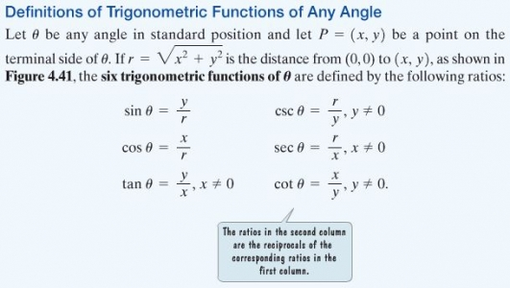
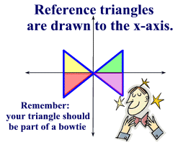A reference triangle is formed by "dropping" a perpendicular from the terminal ray of a standard position angle to the x-axis. Remember, it must be drawn to the x-axis.
Reference triangles are used to find trigonometric values for their standard position angles. They are of particular importance for standard position angles whose terminal sides reside in quadrants II, III and IV. A reference triangle contains a reference angle.
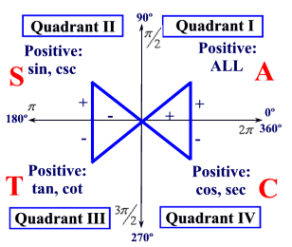
Fill in the table on the next page, defining the Trigonometric Functions of Any Angle. See the bottom of page 333.
Let θ be any angle in standard position, and let P(x, y) be any point on the terminal side of the angle. Let r denote the distance from P(x, y) to the origin.
That is, let r = √ (x² + y²). Then,
sin θ = | csc θ =
cos θ = | sec θ =
tan θ = | cot θ =

CLASS WORK/HOMEWORK:
- Fill in the degrees, radians, and ordered pairs for the special angles on a blank unit circle.

- Find the six trigonometric functions of an angle θ in standard position whose terminal side contains the point (-5, 3). Illustrate the situation.

FRIDAY (9.20.24) A-Day, No Class

